IBuyit Website

Administrator Guide

1. **Product Import**

1.1 Log in as an administrator

**Admin Email**  2x7hkymj@localhost

**Password** mfgC15Mb

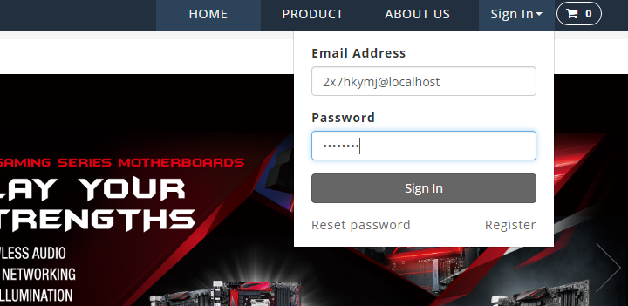

1.2 Enter Import Product Page

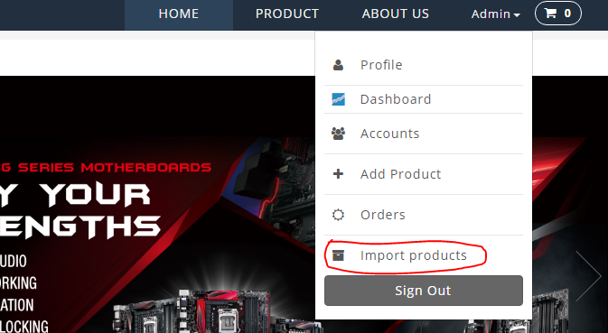

The Product page is like this

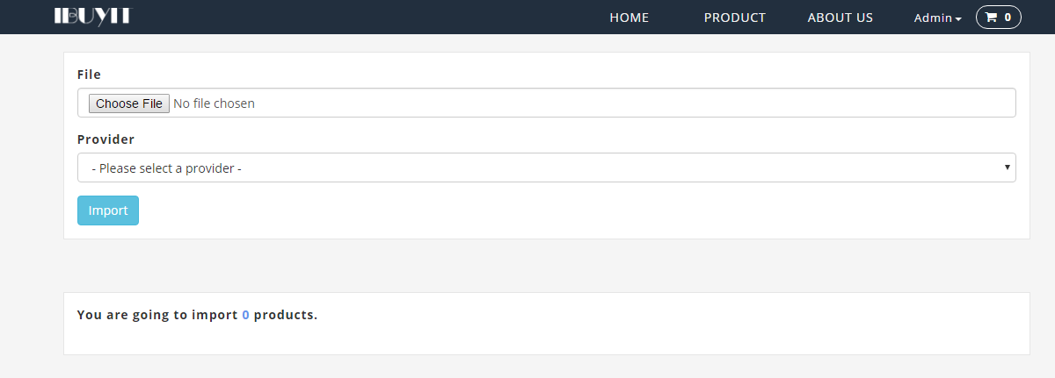

1.3 Choose a Product list file and the corresponding supplier

The sample product list files can be found at project doc folder: “projectdoc\Supplier sample csv” which is provided in the USB stick.

The folder content is:

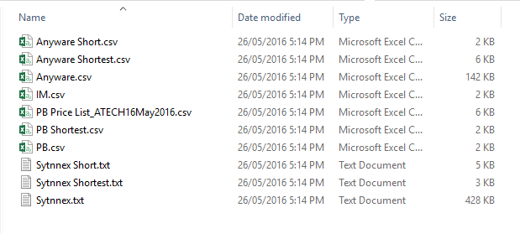

Use the shortest list for simple tests, for example, “Anyware Shortest.csv”. Furthermore, IM is no longer supported in the project. And then, choose the supplier “Anyware”.

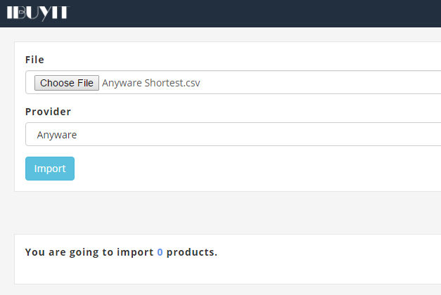

1.4 Press “Import” button to start parsing the product list file, the result will be listed below as:

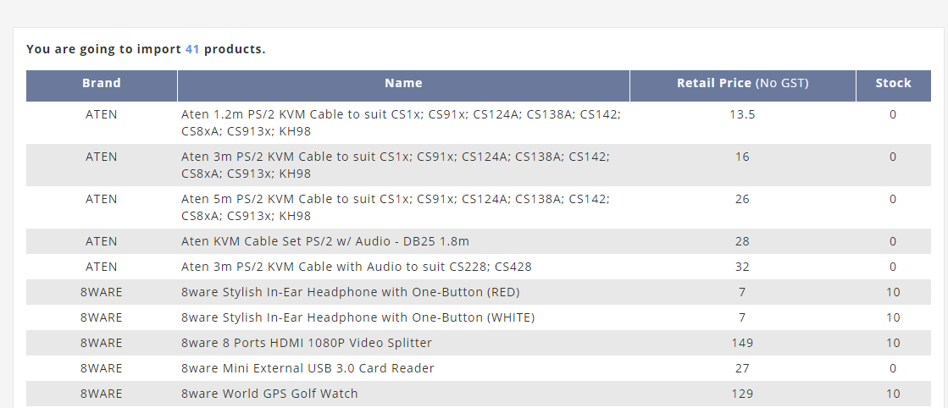

1.5 At the bottom of the list, “Submit” button can be found and press it to save the products into database.

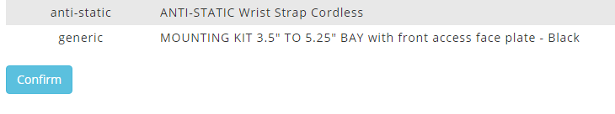

1.6 See the import result

